 | EURO SENIORS  KOPER (Slovénie)  29 Septembre - 4 Octobre 2014 | 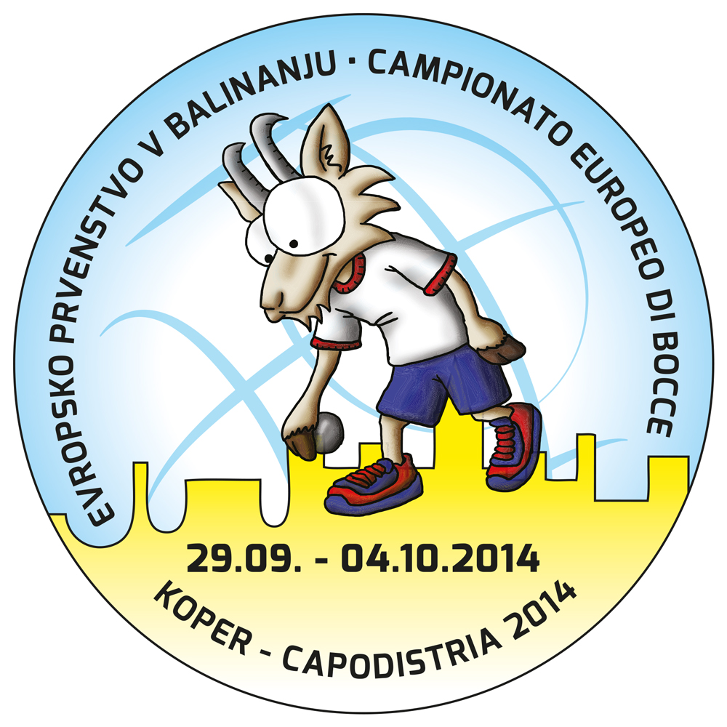

TIR PROGRESSIF - TIRO PROGRESSIVO

QUALIFICATIONS
1. | HUN | FODOR Csaba | 12/41 |  | 9. | SRB | SKAKIC Veselin | 22/41
2. | RUS | BEKHTIN Sergey | 13/46 |  | 10. | MON | CHOISY Steven | 32/43 | Q
3. | FRA | CHIRAT Alexandre | 44/49 | Q | 11. | CRO | BRNIC Leo | 38/47 | Q
4. | NLD | BIERSTEKER Erwin | 11/38 |  | 12. | ITA | ROGGERO Mauro | 39/47 | Q
5. | BIH | RASIC Tomislav | 27/45 | Q | 13. | TUR | RECEP Ali Asker | 31/46 | Q
6. | MNE | DUROVIC Mihajlo | 35/44 | Q | 14. | BUL | RADEV Filip | 16/45
7. | SLO | BORCNIK Ales | 46/50 | Q | 15. | EST | REMMELKOOR Allan | 12/41
8. | SVK | DOMOK | 13/40 |  | 16. | FIN | TÖRRÖNNEN Matti | 18/41

1/4 DE FINALE
1. | BIH | RASIC Tomislav | 27/48
2. | TUR | RECEP Ali Asker | 33/48
3. | MON | CHOISY Steven | 31/43
4. | MNE | DUROVIC Mihajlo | 35/44
5. | CRO | BRNIC Leo | 43/48 |  | Q
6. | ITA | ROGGERO Mauro | 41/50 |  | Q
7. | FRA | CHIRAT Alexandre | 44/48 |  | Q
8. | SLO | BORCNIK Ales | 41/47 |  | Q

1/2 FINALE
1. | SLO | BORČNIK Aleš | 44/51 |  | Q
2. | ITA | ROGGERO Mauro | 44/51 |  | Q
3. | CRO | BRNIĆ Leo | 38/47
4. | FRA | CHIRAT Alexandre | 34/46

FINALE
1. | SLO | BORČNIK Aleš
2. | ITA | ROGGERO Mauro

